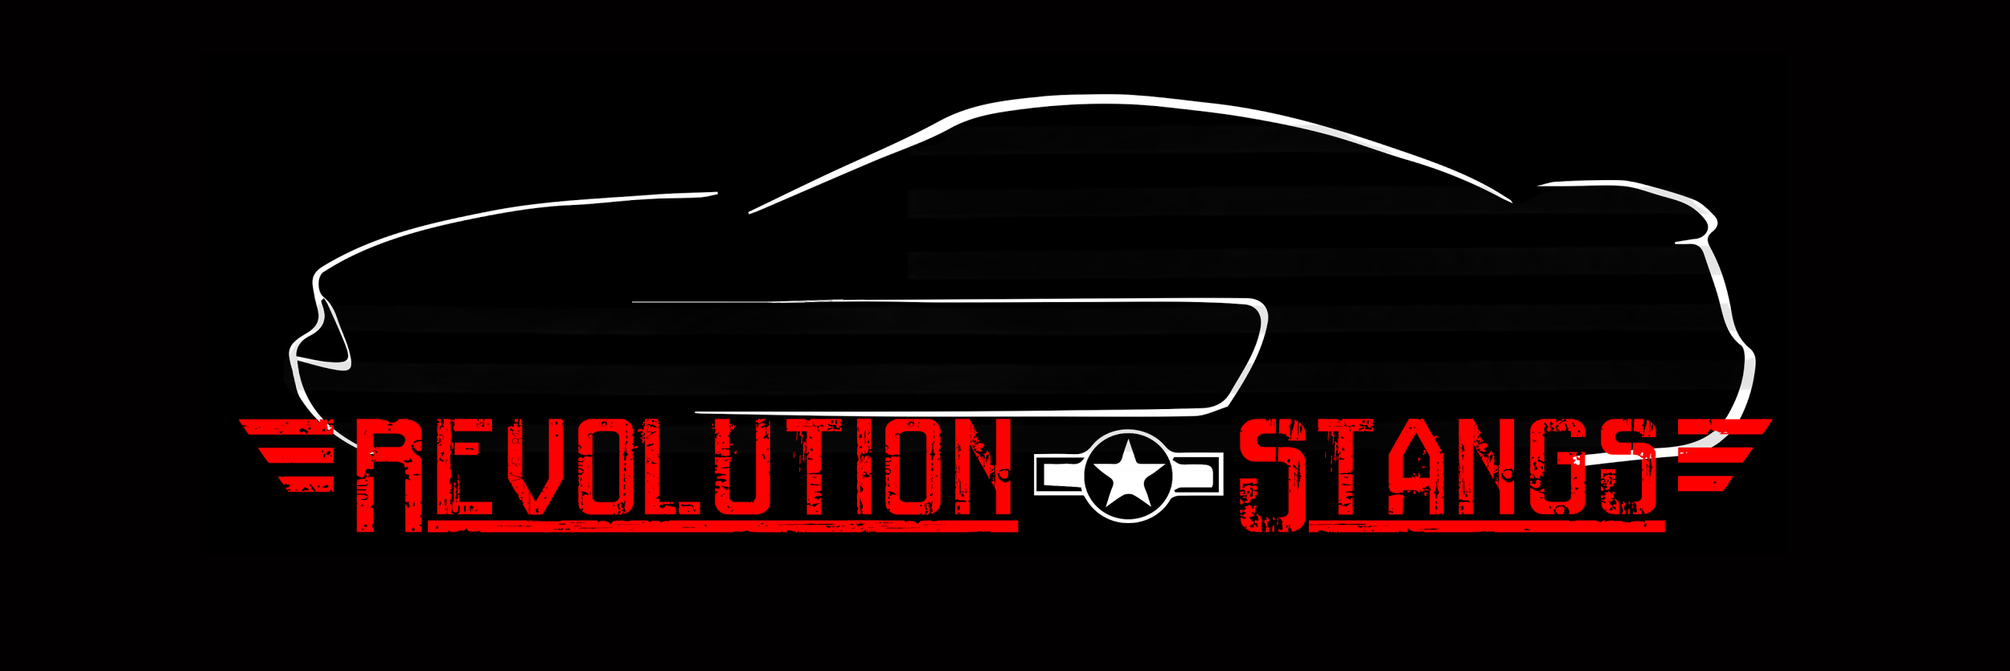
MEMBERSHIP APPLICATION
NAME: _________________________________ DOB: ____________ DATE: _____________
ADDRESS (Include City, State, Zip): ______________________________________________________
EMAIL ADDRESS: ____________________________ PHONE NUMBER: __________________
Instagram name (optional) ? _____________________
Any special talents? (Web design / Video editing/ Photo shop, etc) ________________________________________________________________________________________________________________________________________________________________________
What is your reason for wanting to join Revolution Stangs Mustang Club? ______________________________________________________________________________ How did you hear about us? _____________________________________________________________________ What are your interests within the car community? (Check all that apply)
Car Shows ____ Cruises ____ Monthly Meetings ____ Autocross ____
Sanctioned Drag Races _____ Fundraisers _____ Club Hangouts ____
Opportunities to work on yours and others cars ____
What do you drive?
YEAR: _______ MODEL: __________ COLOR: __________ LICENSE PLATE #____________________
YEAR: _______ MODEL: __________ COLOR: __________ LICENSE PLATE #____________________
I wish to apply for membership to Revolution Stangs Mustang Club. I will try to be an active member of this organization. I understand the probationary period is (3) months before I may a full-fledged member of the club. I also read the by-laws and I agree to the behavior rules & attend the monthly meetings and attend at least one event per month within the three month probationary period. Revolution Stangs DOES NOT condone illegal street racing. If member is found to have participated in street racing they will be removed from this club.
Initial Dues are $20 this due is payable any time within the (3) month probation period. You will not be eligible to become a full-fledged member until dues are paid. You may receive a windshield banner of your choice (x1 Large or x2 Small) upon completion of (3) month probation and payment of dues. You may also choose to put this towards a T Shirt (total of $25). Discount codes will be given upon probation completion.
Yearly Dues of $15 are collected in January and the proceeds go directly to the clubs general fund
APPLICANT SIGNATURE: _____________________________ ____ DATE: _________________
/////////////////////////////////////////////////////////////////// BELOW FOR CLUB TO FILL OUT //////////////////////////////////////////////////////////////////////
Paid: Yes / No Date: Member Name:

